HOW2 VIEW DEVON COUNTY COUNCIL OVER £500 DATA – AS REQUIRED BY LOCAL GOVT TRANSPARENCY CODE 2015
GO TO DCC WEBSITE
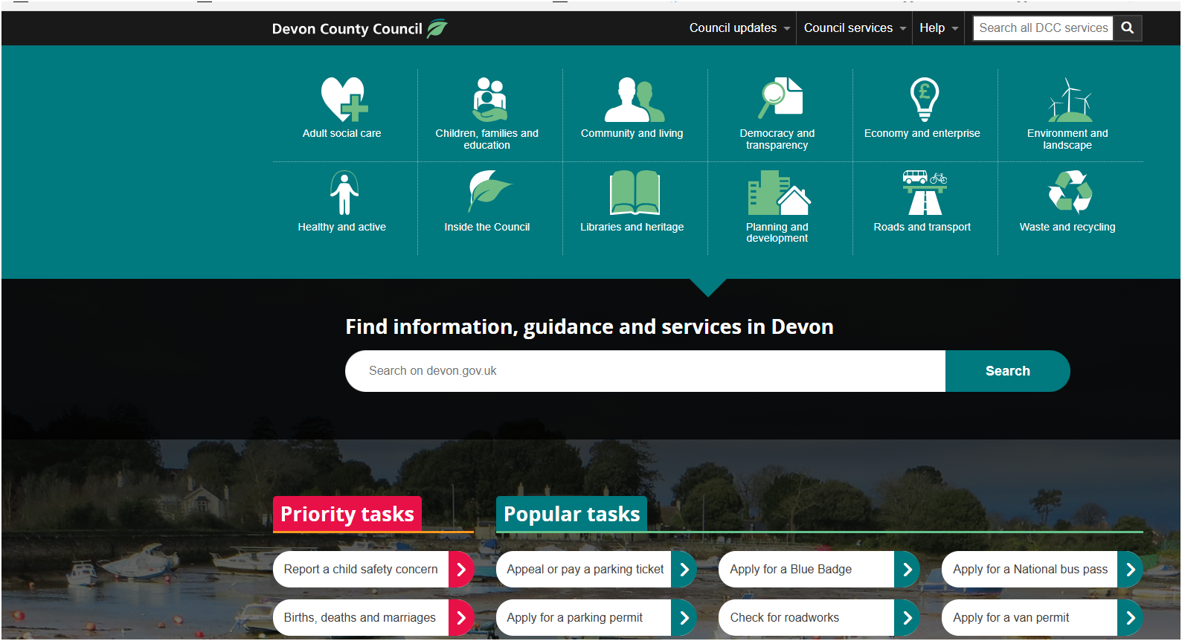
IN SEARCH BAR TYPE OVER 500

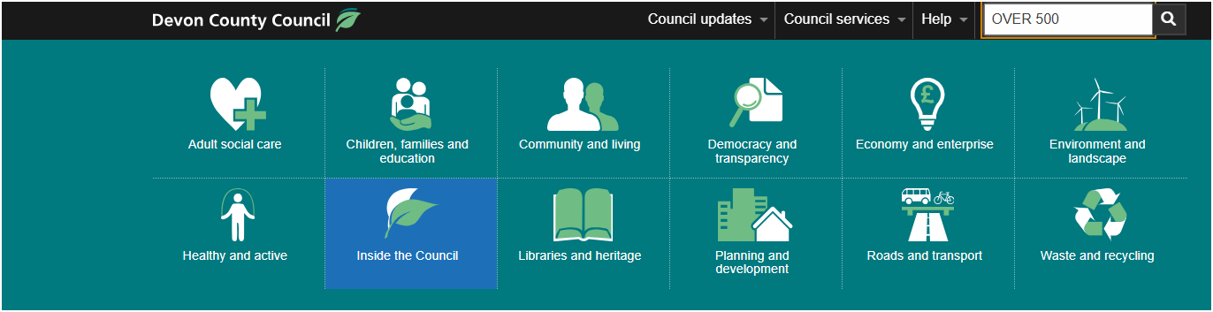
CLICK ENTER
THIS SCREEN APPEARS
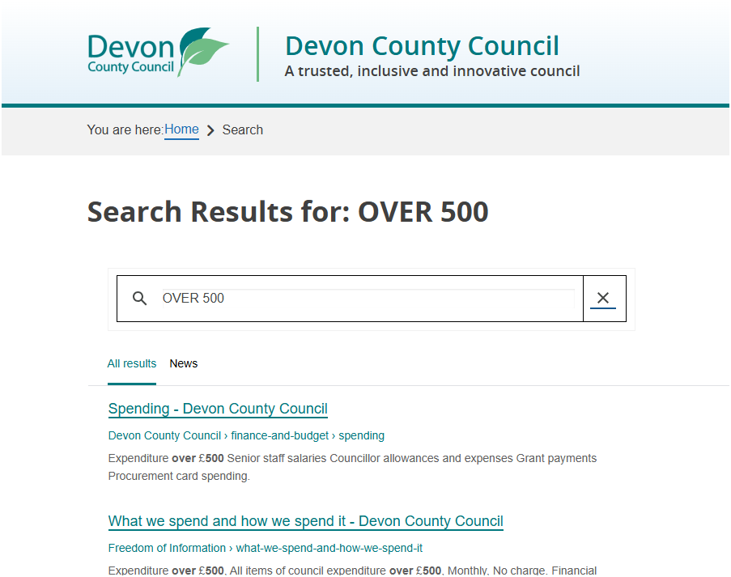
CLICK ON SPENDING DEVON COUNTY COUNCIL
##
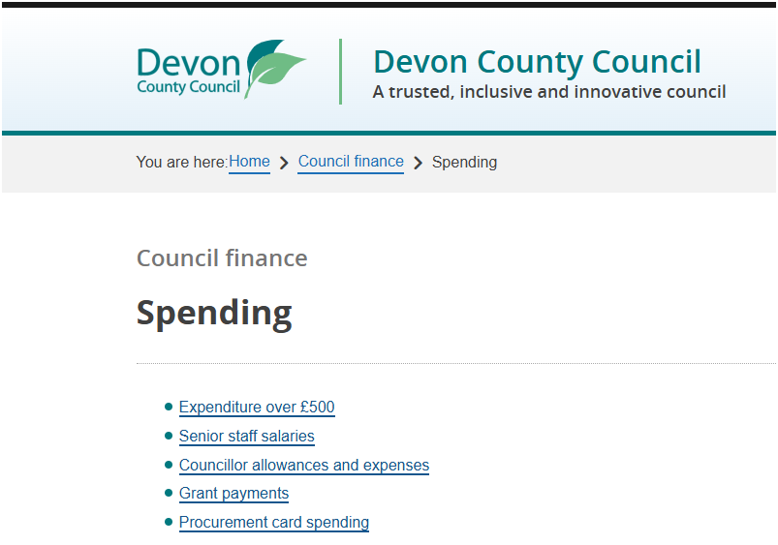 | CLICK ON EXPENDITURE OVER £500

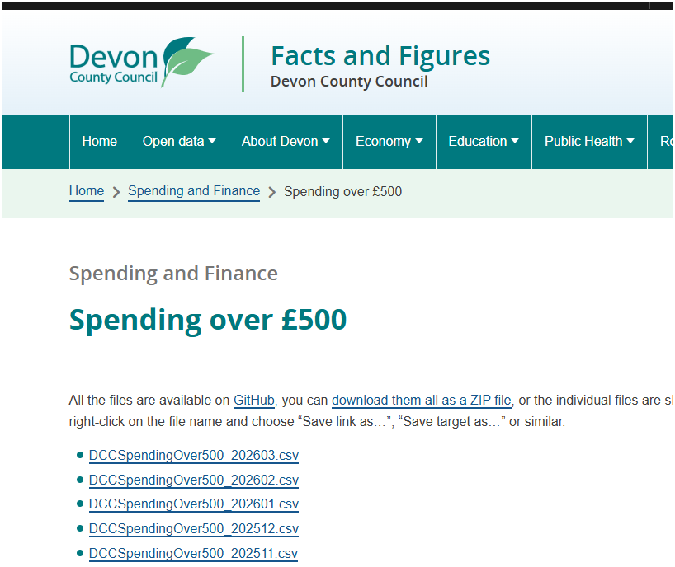 | CLICK ON THE PERIOD YOU ARE INTERESTED IN – FOR OUR EXAMPLE ITS MARCH 2023

HERE IS THE RAW OUTPUT
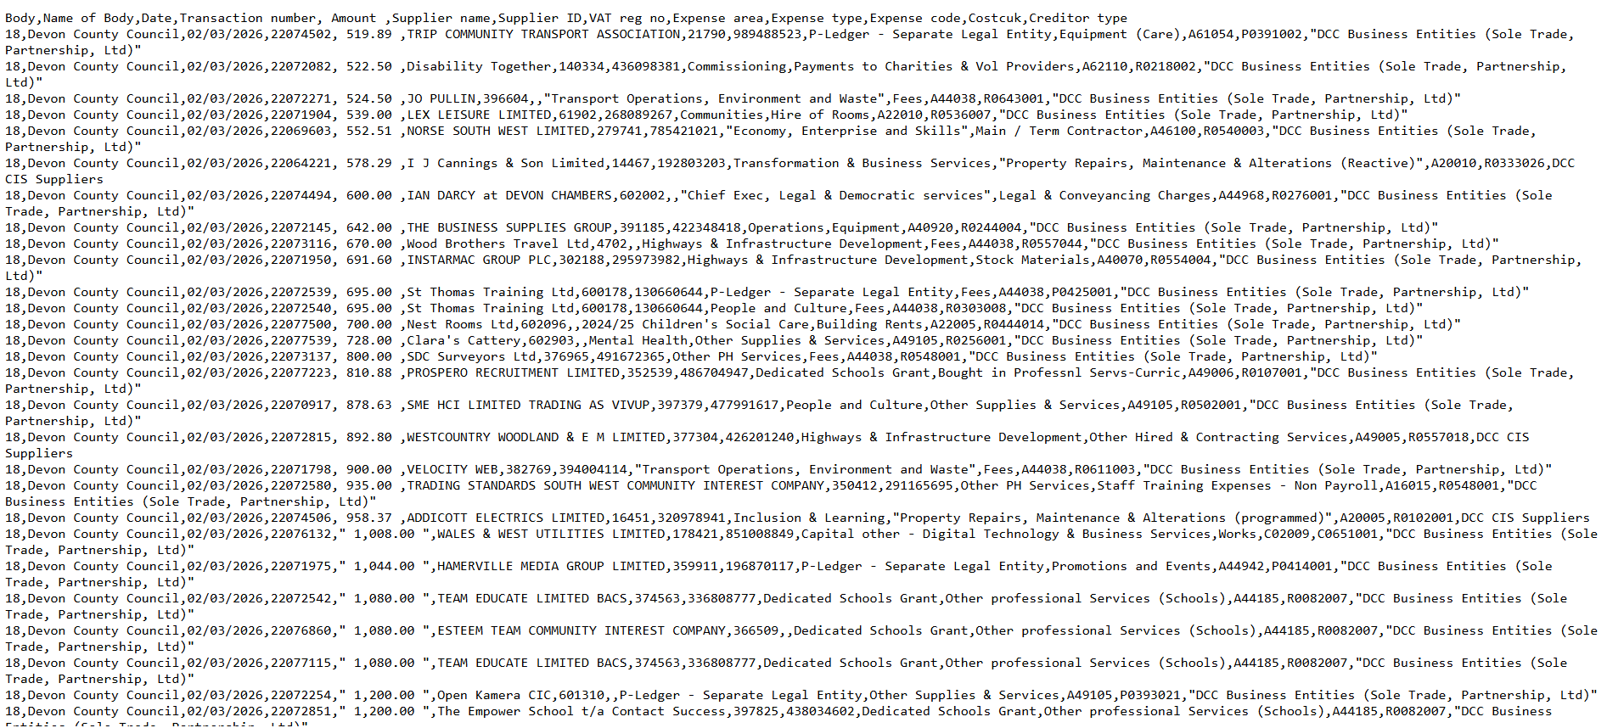

WE NEED TO GET IT INTO EXCEL – SO SELECT ALL DATA BY PRESSING CONTROL + A

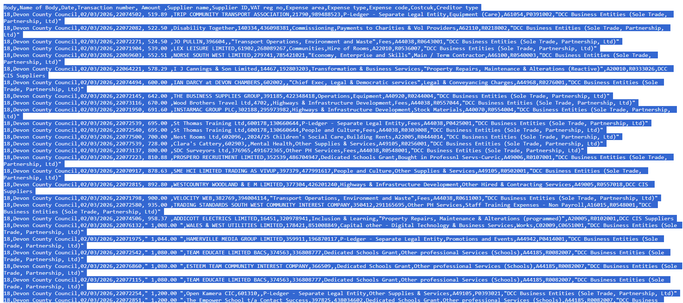
THE WHOLE SCREEN HAS TURNED BLUE TO SHOW DATA HAS BEN CAPTURED

CLICK 3 LINES AT TOP RIGHT OF SCREEN & THEN SELECT SAVE PAGE AS
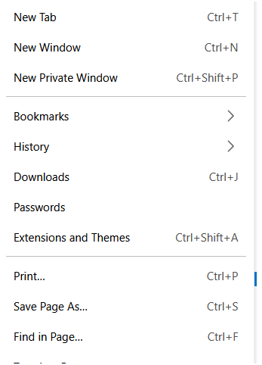

PICK A FILE LOCATION ON YOUR COMPUTER FOR TE DATA TO BE SAVED TO
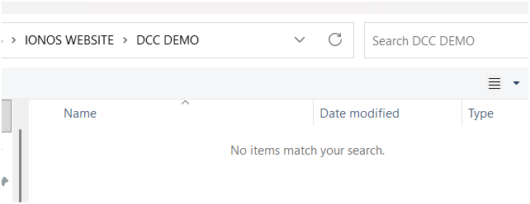

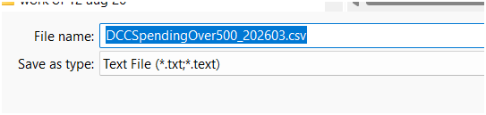
THE FILE IS SAVED WITH TE FILENAME AUTOMATICALLY ADDED FROM THE DCC DESCRIPTION - CLICK ON SAVE BUTTON

GO TO FILE AND DOUBLE LEFT CLICK ON IT TO OPEN IT WITH EXCEL
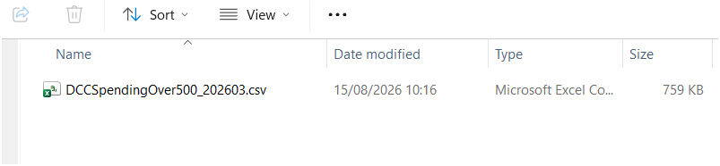

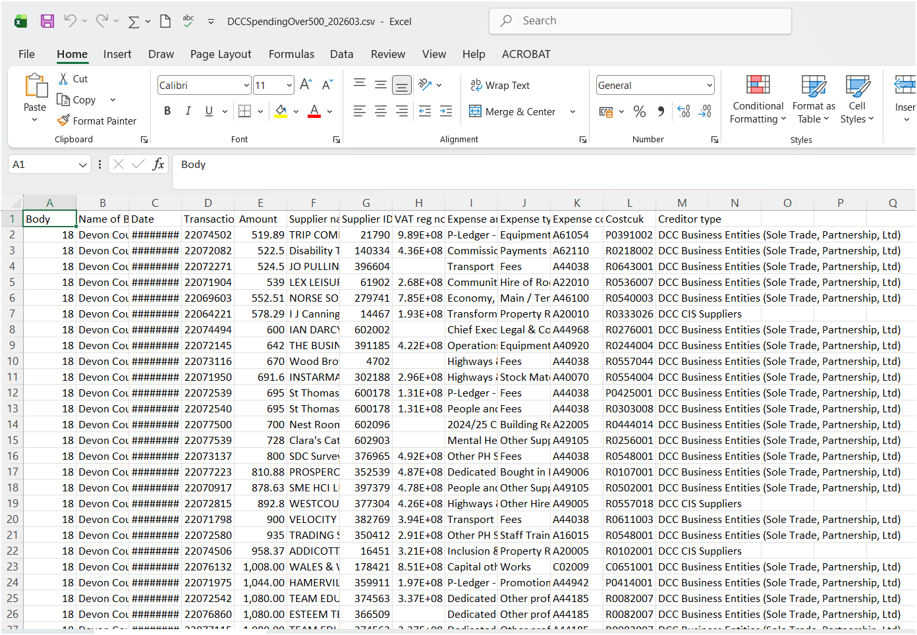
HERE IS THE FILE AS SUPPLIED - WE NEED TO KNOW HOW MANY LINES OF DATA THERE ARE PLUS TOTAL SPEND
PRESS CONTROL + END KEY

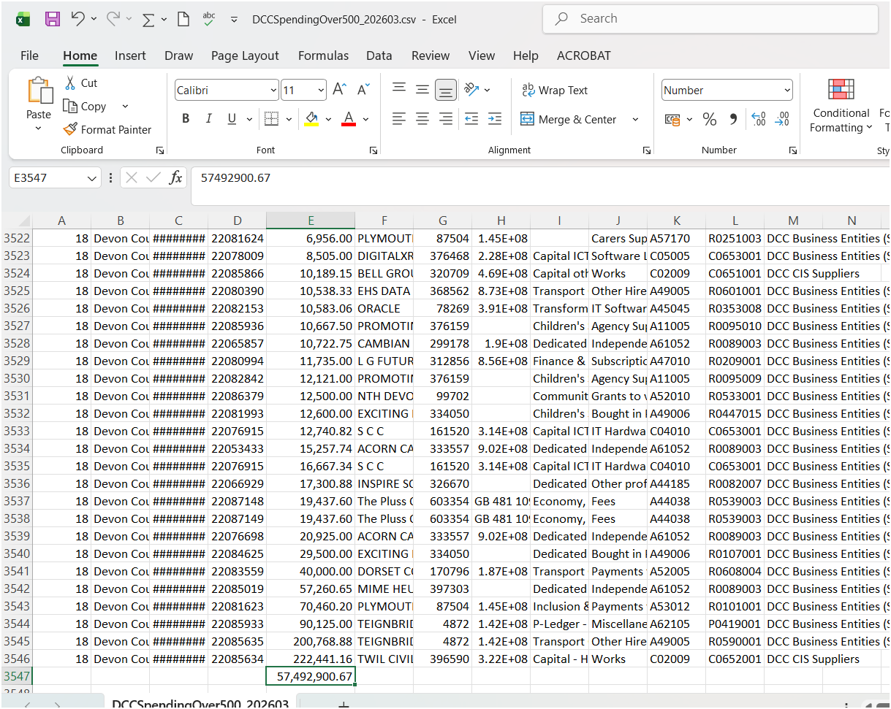
SO HERE WE HAVEA SPREADSHEET WITH 3547 ROWS ( INC 1 HEADER ROW) WITH A VALUE OF £57,492,900.67
WIDEN COLUMN C TO CONFIRM DATA RANGE WHICH SIS MARCH 2026
HAPPY HUNTING – IF YOU HAVE ANY QUERIES THEN PLEASE CONTACT YOUR DCC COUNCILLOR. IT MAY BE AN INTERESTING QUESTION TO ASK
IF THIS DATA HAS BEEN REQUIRED TO BE PRODUCED SINCE THE 2015 LEGISLATION – WHY HASN’T YOUR PARTY BEEN PROACTIVELY PUTTING THIS INTO THE PUBLIC ARENA – IN AN EASY TO UNDERSTAND SUMMARY ?
IS IT PERHAPS YOUR OPINION THAT IT HAS BEEN HIDDEN IN PLAIN SIGHT?
WE NEED THIS AS A STARTING POINT FOR TRANSPARENCY AND THE VALUE FOR MONEY CHECKING PROCESS –
THERE IS NO MAGIC MONEY TREE - ITS YOUR TAXES THEY ARE SPENDING

